Code Review: I2305123
Reviewer: Mark Dell
Date: July 5th, 2023

Bugs

Preventative Action/Safety
- In your modification for each form, the code reads the data from the registry two times. It also assumes that the data wasn’t somehow corrupted or written wrongly. It would be simpler to use Integer.TryParse() to directly convert the registry value to the expected integer. E.g. Integer.TryParse(CommonService.LoadSettingFromRegister("Estimate", "HeaderSpacing"), SetSize)
See: Int32.TryParse Method (System) | Microsoft Learn (Int32 is Integer)
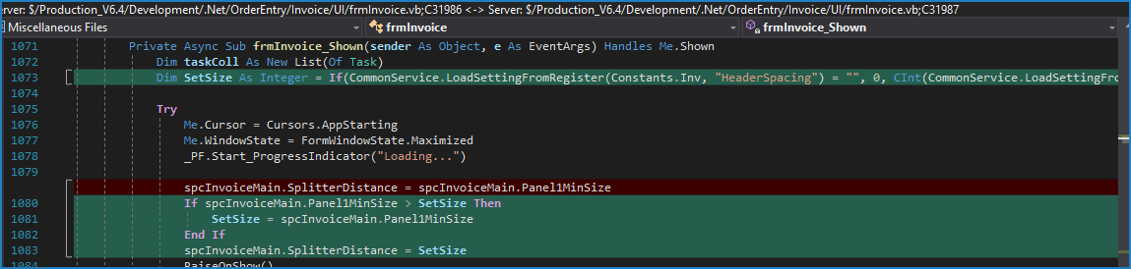
Replacing the “If” statement with the following would be safer and simpler:
If Not Integer.TryParse(CommonService.LoadSettingFromRegister(Constants.Inv, "HeaderSpacing"), SetSize) OrElse
spcInvoiceMain.Panel1MinSize > SetSize Then
SetSize = spcInvoiceMain.Panel1MinSize
End If
Note that this applies to all code files you made this change to.

Design/Architecture (Duplication, appropriate project, namespaces, maintainability)

Data Model (Naming, good design, needs index?)

Performance (Minimize DB hits, excessive loops, queries, scalable)

UI (Alignment, naming, standardization, tab order)

Error Handling (Behind events, appropriate parameter checking)

Cleanup (Dispose code, remove handlers, large data objects)

Readability (Well-named variables, methods, clear algorithm, is it understandable)

Comments (Useful, explains why rather than how)

Message Boxes (Grammar, spelling, captions, appropriate icons)

Ticket Management (Release Branch?, Testing Notes)

Extras

